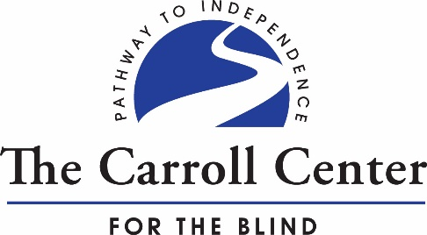

The Carroll Center for the Blind
770 Centre Street
Newton, MA 02458
(617) 969-6200

VOLUNTEER APPLICATION

Name: Click or tap here to enter text.

Address:Click or tap here to enter text.

Home Phone: Click or tap here to enter text.

Work Phone: Click or tap here to enter text.

Email: Click or tap here to enter text.

Volunteer Interests (at the Center).

☐ Summer Youth Program | ☐ Carroll Store | ☐ Dining Hall
☐ Brailler Servicing | ☐ Grounds/ Maintenance | ☐ Administrative Support
☐ Teaching Assistant | ☐ Sighted Guide Sailors | ☐ Special Event  (ie. Walk for Independence)

Times Available: ☐ Daytime ☐ Evenings ☐ Weekdays ☐Weekends

How many days a week? # days per week: Click or tap here to enter text. # hours: Choose an item.

Restrictions (if any): Click or tap here to enter text.

Reference: Individual who can be contacted (non-family member)

Name: Click or tap here to enter text. Phone: Click or tap here to enter text.

Address: Click or tap here to enter text.
Please continue to next page…

1. What experiences/skills to you bring to a volunteer position?

Click or tap here to enter text.

2. What volunteer work have you done in the past?

Click or tap here to enter text.

3. Do you speak any other languages than English?

Click or tap here to enter text.

4. Do you have a family member who is visually impaired?

Click or tap here to enter text.

5. Are you doing this volunteer activity as a requirement for a school/course? If so, please list the program and contact:

Click or tap here to enter text.

6. Will your hours need to be verified?

Click or tap here to enter text.

Please attach a resume if you have one and/or list special skills you have, especially technology/computer programs.

